Multi Judging LLM system for Exam Answer Evaluation

Abstract
Large Language Models (LLMs) have demonstrated strong performance in automated short answer and essay grading, achieving competitive alignment with human evaluators across multiple educational domains. However, most existing LLM-based grading frameworks rely on single-pass, single-judge inference, leading to instability, score variance, and unquantified uncertainty. Such monolithic evaluation strategies fail to model examiner subjectivity and often lack mechanisms for reliability control or confidence estimation, limiting their suitability for high-stakes academic assessment.
This work proposes a Multi-Judging LLM System for Exam Answer Evaluation, a reliability-aware grading architecture that models examiner variability through structured multi-judge aggregation. The system employs multiple LLM-based evaluators instantiated with distinct grading personas (e.g., strict, moderate, lenient) to simulate heterogeneous human grading behaviors. Each evaluator performs rubric-guided assessment of student responses, and self-consistency is incorporated via repeated stochastic sampling to mitigate single-pass randomness. The resulting scores are aggregated using a weighted consensus mechanism, and inter-judge variance is explicitly quantified to produce a disagreement-based confidence measure.
The proposed framework is evaluated on a publicly available short answer grading dataset and compared against a single-LLM baseline. Performance is assessed using Mean Absolute Error (MAE), Pearson correlation, and agreement metrics with human-assigned scores. Experimental results demonstrate improved alignment stability and reduced grading variance relative to single-judge evaluation. By integrating multi-judge reasoning, stochastic self-consistency, and uncertainty-aware aggregation, this study advances the development of robust and explainable LLM-based assessment systems for educational applications.

Literature Review
[1] Chan et al. propose ChatEval, a multi-agent LLM-based evaluation framework that improves text quality assessment by simulating collaborative human evaluation through agent debate. Unlike single-agent LLM evaluators, ChatEval assigns diverse personas to multiple LLM agents and enables structured interaction using different communication strategies. Experiments conducted on open-ended question answering and dialogue generation benchmarks demonstrate that the multi-agent approach achieves higher accuracy and stronger correlation with human judgments compared to single-agent LLM evaluation and traditional automatic metrics. The results highlight the importance of role diversity and controlled interaction in improving the reliability of LLM-based evaluators.

[2] Metzler et al. examine the use of instruction-following large language models for automatic short answer grading, with a particular focus on rubric adherence and grading consistency. Using both a standard computer science dataset and a rubric-based German dataset, the study evaluates multiple proprietary and open-source LLMs under varying prompting and temperature configurations. The results show that rubric-based grading improves interpretability and accuracy compared to reference-answer-based approaches, while few-shot prompting enhances performance at the cost of reduced consistency. The findings highlight both the promise and remaining challenges of LLM-based grading, particularly regarding reproducibility and reliable rubric completion.

[3] Duong and Chai propose an LLM-based framework for automatic grading of short answers in software engineering courses using both embedding-based similarity scoring and completion-based prompting. Their approach extends traditional autograding by incorporating retrieval-augmented generation to provide relevant course content as grading context. Experiments on a public computer science dataset and a newly introduced software engineering dataset demonstrate that completion-based LLM grading, especially when enhanced with contextual retrieval, achieves strong alignment with human grading while avoiding the need for extensive model training.

[4] Grévisse investigates the application of large language models for automatic short answer grading in undergraduate medical education using a multilingual, real-world dataset. By comparing GPT-4 and Gemini 1.0 Pro against human evaluators across multiple courses, the study demonstrates that LLMs can achieve moderate agreement with human grading and high precision for identifying fully correct answers. The analysis further examines grading consistency, bias, and the influence of answer length and language, highlighting both the potential of LLM-based grading to reduce teacher workload and the necessity of continued human oversight, particularly for partially correct responses.

[5] Wang et al. introduce self-consistency, a decoding strategy that improves reasoning performance in large language models by aggregating multiple sampled reasoning paths rather than relying on greedy decoding. Through extensive experiments on arithmetic, commonsense, and symbolic reasoning benchmarks, the approach consistently outperforms traditional decoding and ensemble-based methods across multiple model scales. The results demonstrate that leveraging agreement among diverse reasoning paths leads to more reliable final answers, highlighting self-consistency as an effective and training-free method for enhancing LLM reasoning accuracy.

[6] Hu et al. propose a multi-agent debate framework for LLM-based evaluation that replaces static aggregation methods with iterative collaborative reasoning among multiple judges. By formalizing the debate process using a latent concept model, the authors theoretically and empirically demonstrate that debate-based judgment improves accuracy over majority voting. To address computational overhead, the framework introduces an adaptive stability detection mechanism based on Beta–Binomial mixture modeling and Kolmogorov–Smirnov testing, allowing the debate to terminate once consensus stabilizes. Experiments across diverse reasoning, alignment, and multimodal benchmarks show that the proposed approach achieves higher evaluation accuracy while maintaining efficiency.

[7] You et al. present a comprehensive survey of the Agent-as-a-Judge paradigm, tracing the evolution from single-pass LLM-based evaluators to agentic systems capable of planning, tool use, memory retention, and multi-agent collaboration. The survey organizes existing methodologies into a unified taxonomy and reviews their applications across general and professional domains, including education, law, medicine, and finance. By highlighting the limitations of traditional LLM-as-a-Judge systems and synthesizing emerging agentic approaches, the paper provides a structured roadmap for developing more robust, verifiable, and fine-grained AI evaluation frameworks.

[8] Pack et al. investigate the validity and reliability of large language models for automated essay scoring in the context of English language learner writing. Using a real-world placement test dataset, the study compares four prominent LLMs against expert human raters across two grading instances. The results indicate that while models such as GPT-4 can achieve good agreement with human scores and strong intrarater reliability, LLM-based grading remains non-deterministic and subject to performance drift over time. The findings highlight both the potential of LLMs to reduce grading workload and the need for careful reliability analysis before deploying such systems in educational assessment.

Model Architecture:
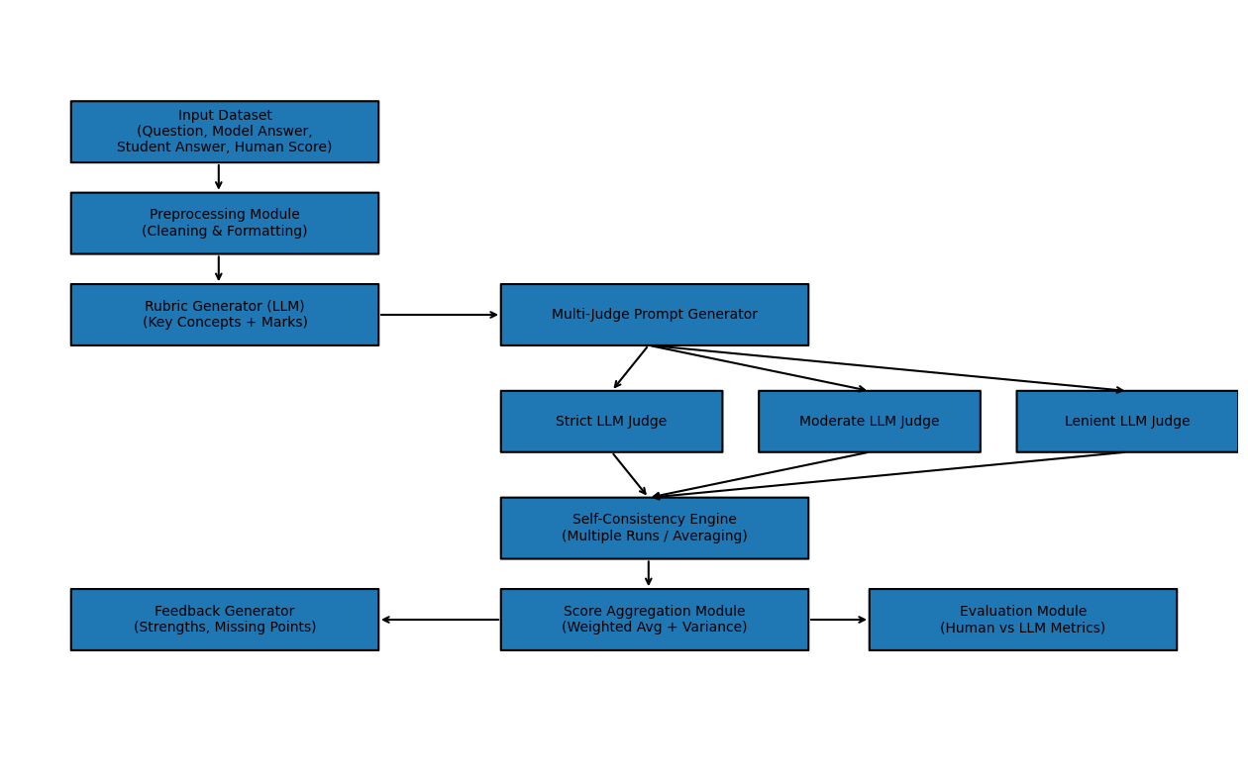

References:
[1] ChatEval: Towards Better LLM-based Evaluators through Multi-Agent Debate https://arxiv.org/abs/2308.07201
[2] Computer-Assisted Short Answer Grading Using Large Language Models and Rubrics
[3] Automatic Grading of Short Answers Using Large Language Models in Software Engineering Courses
[4] LLM-Based Automatic Short Answer Grading in Undergraduate Medical Education
[5] Self-Consistency Improves Chain of Thought Reasoning in Language Models
[6] Multi-Agent Debate for LLM Judges with Adaptive Stability Detection
[7] A Survey on Agent-as-a-Judge
[8] Large Language Models and Automated Essay Scoring of English Language Learner Writing: Insights into Validity and Reliability

